Serial Communications Repeater
Introduction
- Open the included code file 'Repeater.ino'.
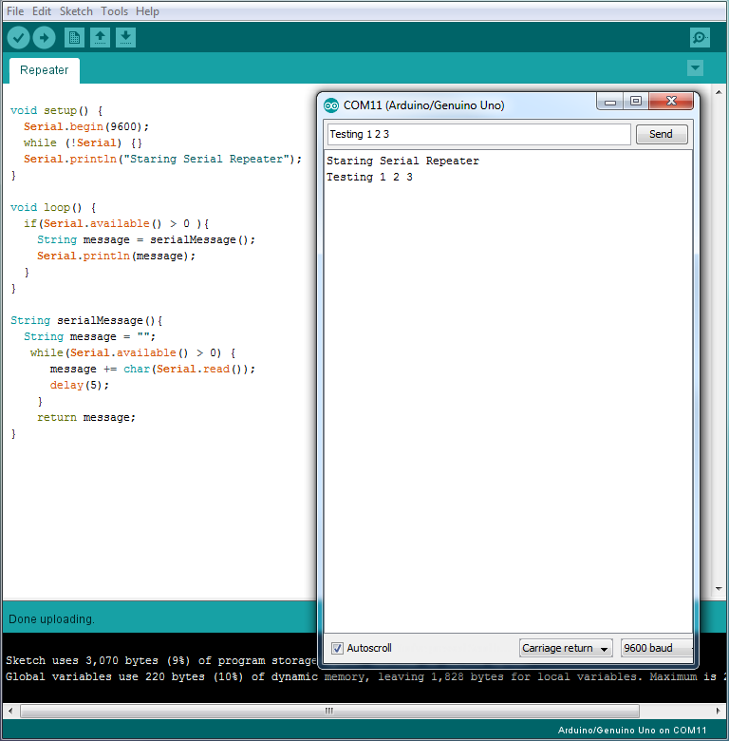
This sketch is designed to listen to any messages written to the serial line from Arduino Serial Monitor. If any are detected, the Arduino will repeat that message back the serial line, and it will be displayed on the monitor.
- Test this process by uploading the program to your Arduino and then typing some message into the Serial Monitor as shown below.

Code Walkthrough

void setup() {
Serial.begin(9600);
while (!Serial) {}
Serial.println("Starting Serial Repeater");
}
The setup function starts by initializaing a Serial connection at 9600 baud. Next, it waits until the Serial port is ready. Finally, it prints a message to be displayed by the Serial Monitor showing the device has started.
void loop() {
if(Serial.available() > 0 ){
String message = serialMessage();
Serial.println(message);
}
}
The loop function continually checks the serial buffer using the Serial object's function available() to see how many characters are in the buffer. If that number is more than zero, it calls the serialMessage() function to extract those characters out. It puts those characters into a variable called message. Finally, it writes that message back to the serial line using Serial.println().
String serialMessage(){
String message = "";
while(Serial.available() > 0) {
message += char(Serial.read());
delay(5);
}
return message;
}
The serialMessage() function starts by creating a new empty string called message. Then, while there are characters to read from the serial device, it reads 1 at a time and appends them to the message varaiable. It waits 5 milliseconds between reading each character. Finally, it returns that message.

